**Occ Therapy – ALUL Interactives Overview**

**Week 1**

* Revisit Planes/Sections (already available) <https://adelaide.h5p.com/content/1291110587513911059>

**Week 2**

* Drag/Drop Label the Femur/Hip Osteology & Arthrology
* Drag/Drop Label Gluteal Musculature

**Week 3**

* Drag/Drop Label Knee ligaments (3D rotation?)
* Drag/Drop Label Leg Musculature (anterior posterior media & lateral)

**Week 4**

* Drag/Drop Label Leg Surface Anatomy (review)
* Drag/Drop Label Lower Leg Musculature
* Drag/Drop Label foot osteology (tarsals+)

**Week 5**

* Draw the Lumbosacral Plexus
* Draw the nervous path
* Draw the main arterial path

**Week 6**

* Drag/Drop Label shoulder girdle (scapula + clavicle) osteology

**Week 7**

* Drag/Drop Label Shoulder Girdle Musculature
* Drag/Drop Label Rotator Cuff

**Week 8**

* Drag/Drop Label Antero/posterior upper arm musculature (3D rotation)

**Week 9**

* Drag/Drop Label Antero/posterior forearm musculature (3D rotation)

**Week 10**

* Drag/Drop Label hand osteology (carpals+)

**Week 11**

* Draw the brachial Plexus
* Draw the nervous path
* Draw the main arterial path

**Week 2**

* Drag/Drop Label the Femur/Hip Osteology & Arthrology
* Drag/Drop Label Gluteal Musculature

**Anterior View**

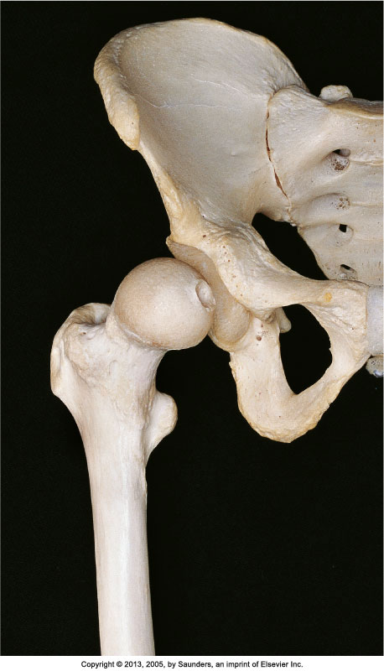

**Anterior View Labelled**

**Note:** No label for pectin pubis & ala of sacrum 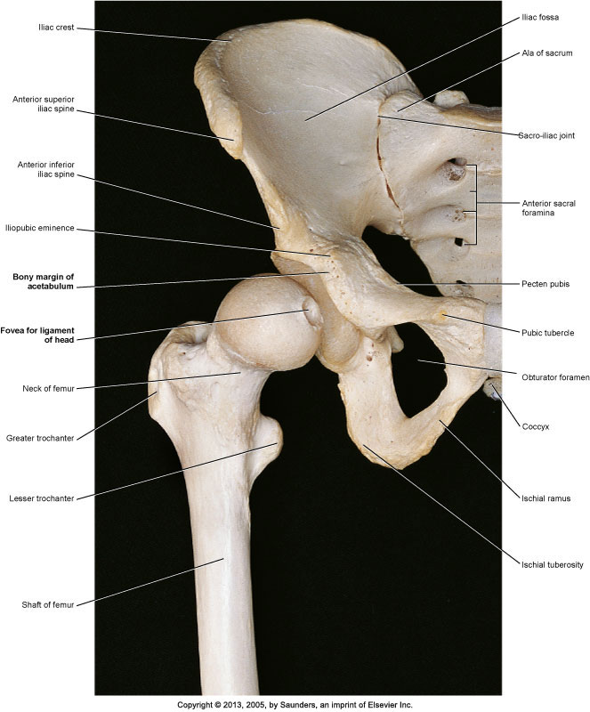

**Posterior View**

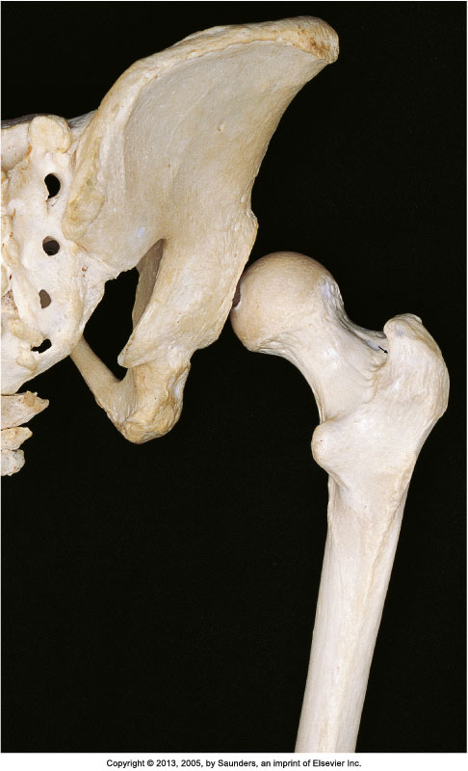

**Posterior View Labelled**

**Note:** No label for median sacral crest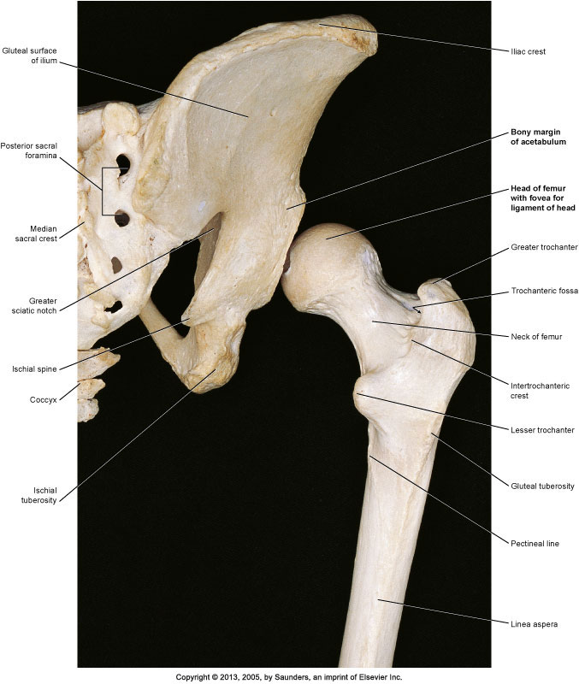

**Posterolateral View**

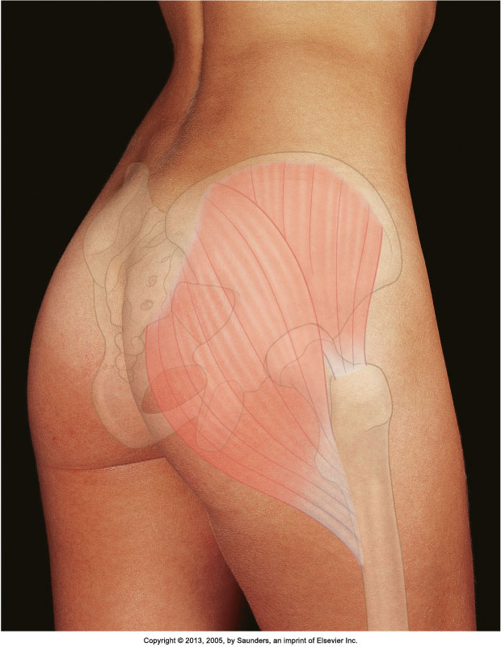

**Posterolateral View Labelled**

**NOTE:** Replace Natal Cleft Label with Coccyx

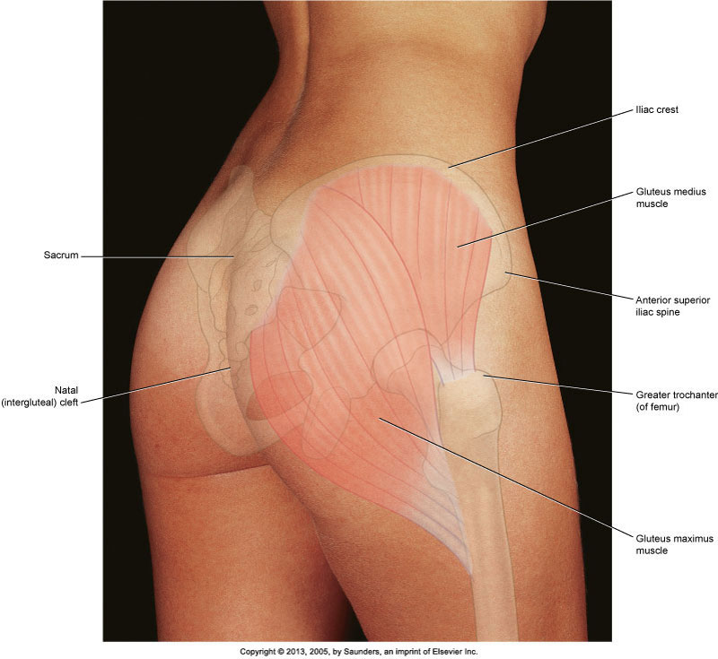

**Week 3**

* Drag/Drop Label Knee ligaments
* Drag/Drop Label Leg Musculature (anteromedial)

**Anterior View**

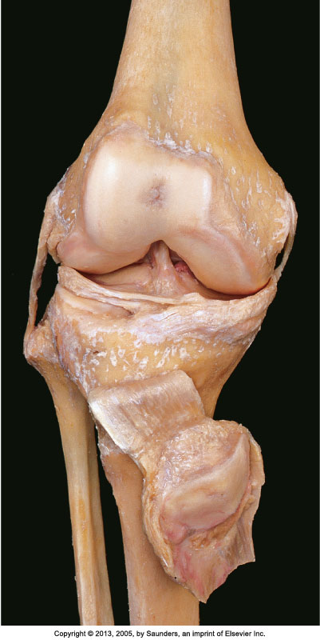

**Anterior View Labelled**

**Notes:**

No label for popliteus tendon

Include Tibial (Medial) collateral Ligament & Fibular (Lateral) collateral Ligament

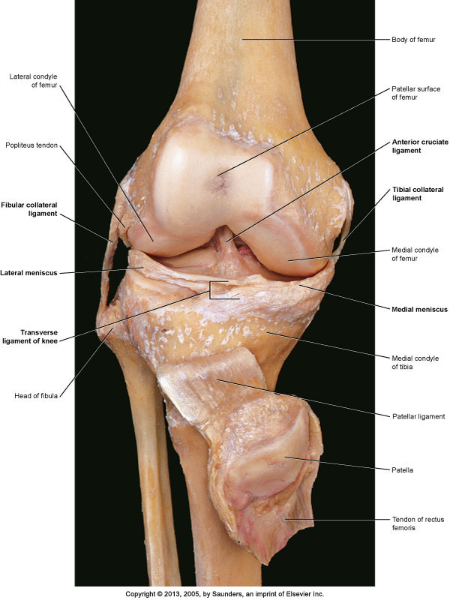

**Posterior View**

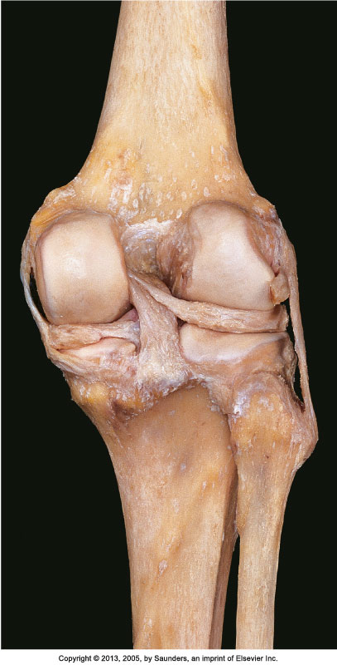

**Posterior View labelled**

**Note:** No label for popliteus tendon

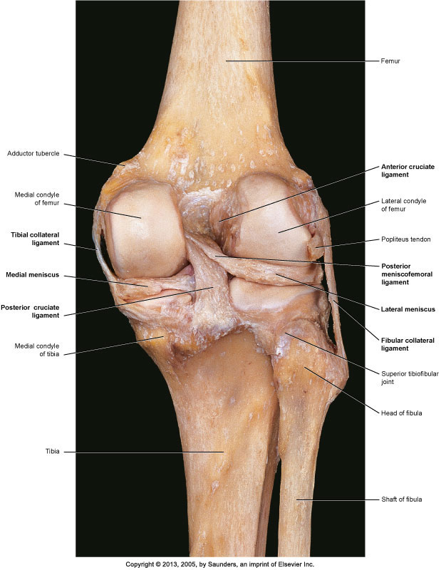

**Anteromedial View**

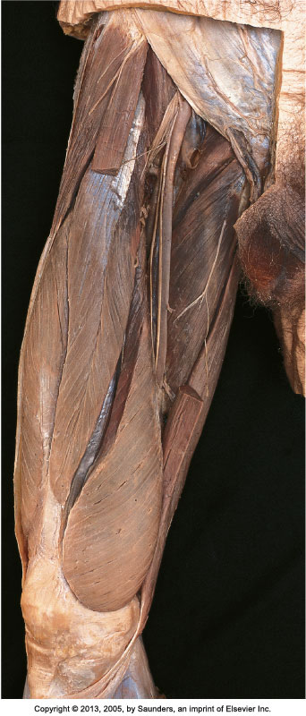

**Anteromedial View labelled**

**Notes:**

**Static labels for**: ASIS, Inguinal Ligament, Anterior Abdominal Wall, Patella, Femoral Vein/Artery/Nerve, Great Saphenous Vein (Cut), Sartorious muscle (Cut) – both ends

**No Labels for:** Deep circumflex iliac artery, Nerve to Sartorious muscle, superficial inguinal ring, Cutaneous branch of obturator nerve, saphenous cutaneous nerve, Nerve to vastus medialis, vaso-adducotry lamina of adductor canal,

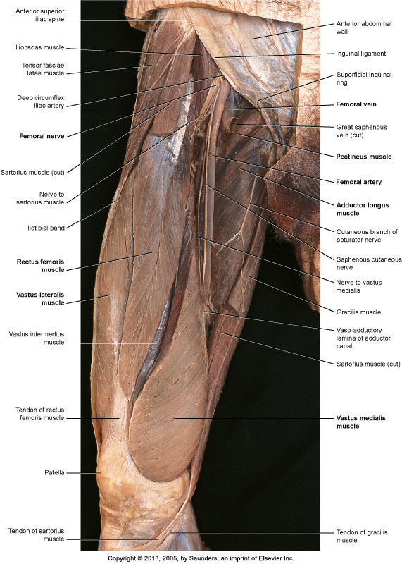

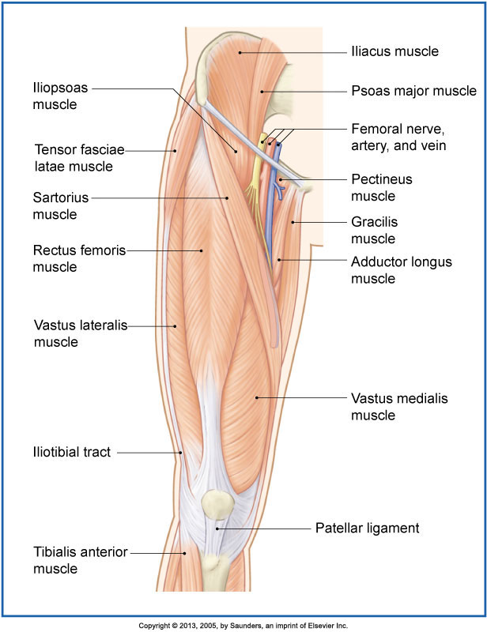

**Posterior View**

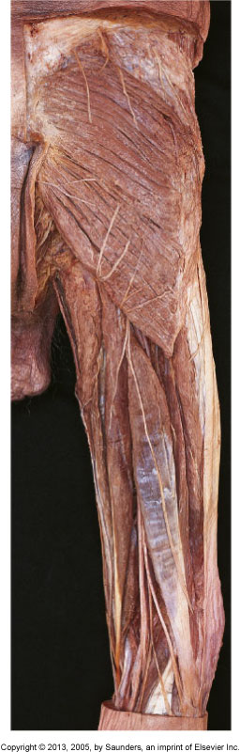

**Posterior View labelled**

**Notes:**

**Static labels for**: Thoracolumbar fascia, position of greater trochanter, Vastus Lateralis muscle, Tibial Nerve, Common Fibular Nerve,

**No Labels for:** Any of the proximal nerves, (i.e. Iliohypograstic, inferior clunial, etc) + lateral sural cutaneous nerve, Lateral head of gastrocnemius

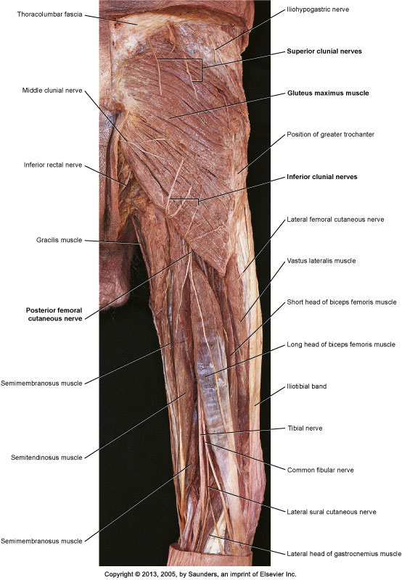

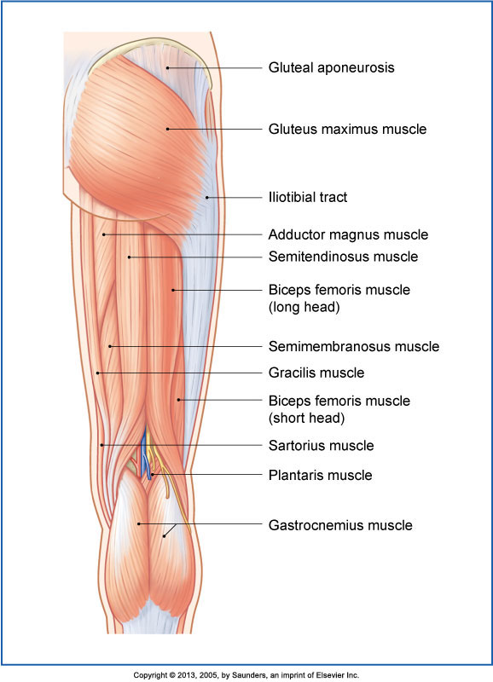

**Week 4**

* Drag/Drop Label Leg Surface Anatomy (review)
* Drag/Drop Label Lower Leg Musculature
* Drag/Drop Label foot osteology (tarsals+)

**Anterior View**

**Note:** Crop male genitalia



**Anterior View Labelled**

**Note:** Crop male genitalia

**Static Labels for**: Oblique & Rectus Abdominis

**Add a Label for** Tendon of Rectus Femoris

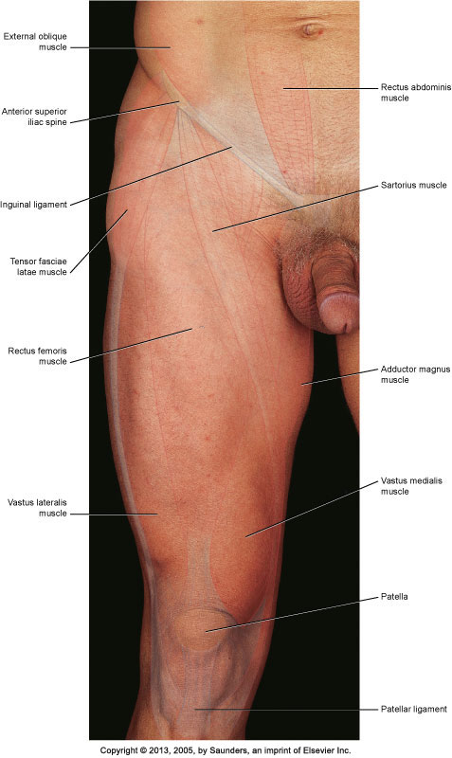

**Posterior View**

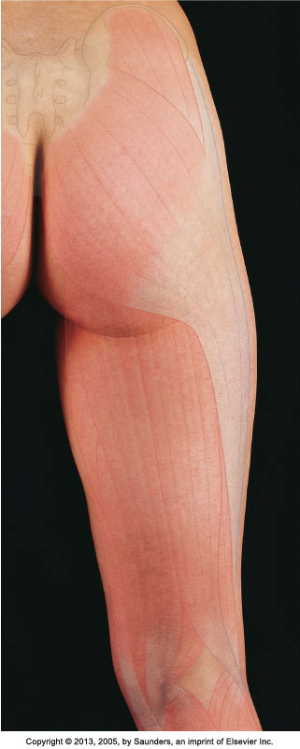

**Posterior View Labelled**

**Notes:**

**No labels for:** intergluteal cleft, gluteal fold, popliteal fossa

**Static label for:** Iliac crest & greater trochanter of femur,

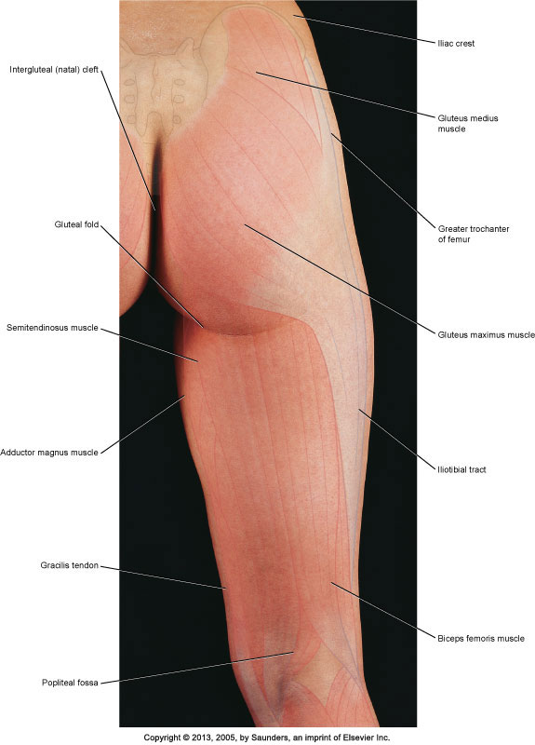

**Anterolateral Leg View**

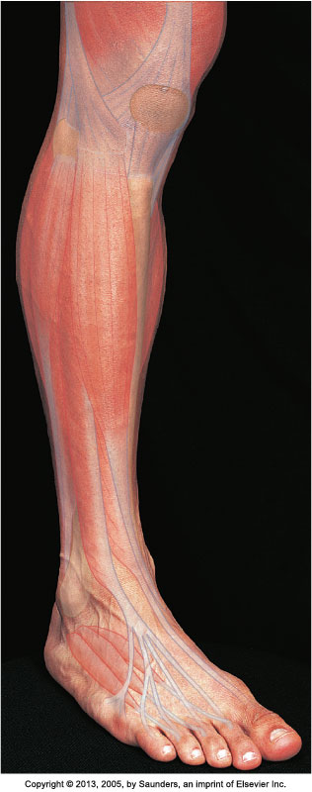

**Anterolateral Leg View Labelled**

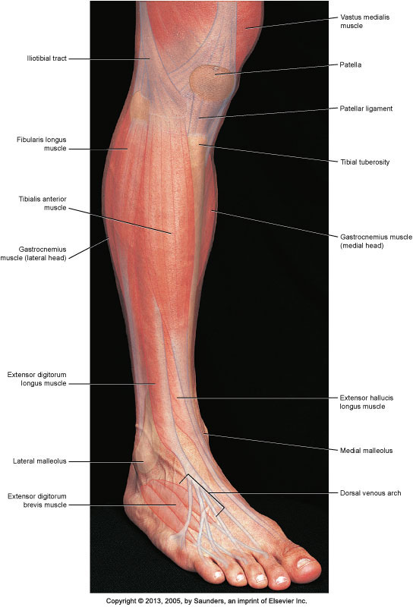

**Posterior Leg**

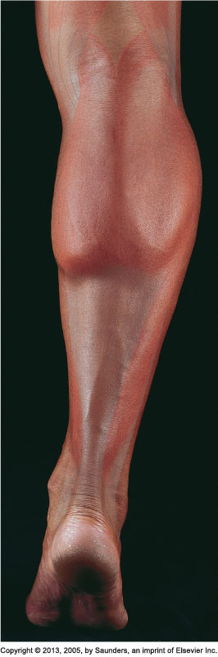

**Posterior Leg Labelled**

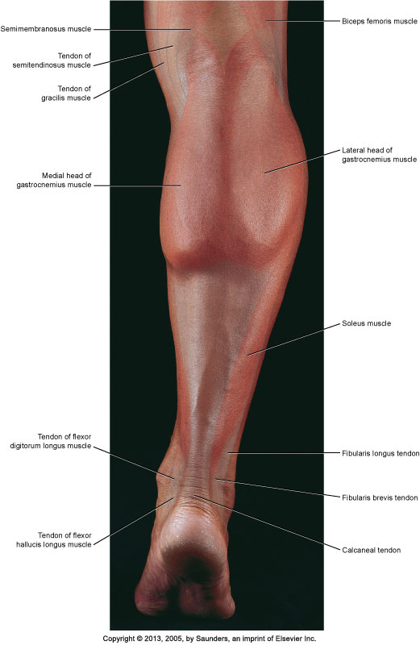

**Foot Osteology Plantar View**

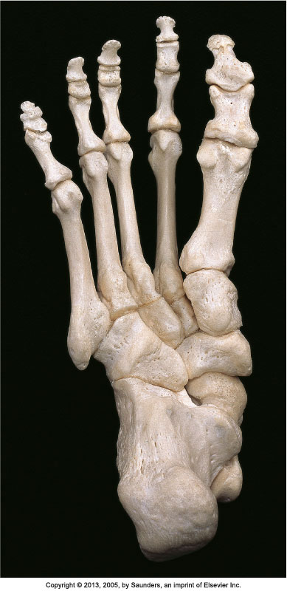

**Foot Osteology Planar View Labelled**

**Note:** No label for tuberosity’s, base, head, body, groove for tendons

